There are many things that you can so in after effect in your videos
Why to do After Effect, why to use after effect. What are its purposes
There are two purposes that are:-
- Motion Graphics
- Compositing
Motion graphics is that you have seen text animation or a box(graphic) moving,rotating and it get opened. Images moving such type of animation on some advanced level means we will start motion graphics from basic to advanced
Second is compositing means in one scene you bring two or more different places and include them in your scene For example you must have seen many movies for example superman is flying in the air which is actually green screen and the green screen video green color get composite(or replaced)(who knows) with other outer scene that thing is called compositing
Another example is that the animals you see in movies like tiger which is 3d animated and it is added in the scene
So Where we add two or three things in one scene and create a new scene that is called compositing How we will do or how much we will do we will start from basic
Teacher assumes that the viewer is one who has not even touched after effect or other editing software
Teacher have promised that he will make us expert and he will start from basic
This lesson is like an announcement that we are starting after effect So not much will be done in this lesson
Teacher will show u interface that what type of interface it has and what basic work can be done and he will do some things or work here

Author's Note:-

When you open the after effect ( not an already made aftereffect file ) window then two windows are shown usually the top window will give you option to open an existing after effect file or create new open and the bottom window will have a untitled after effect file where you can work and save your file
If you choose create new project then top window will be removed and the bottom window will remain maybe when we click on open project then top will be removed(who knows) and bottom window will stay aand will contain the opened project of after effect
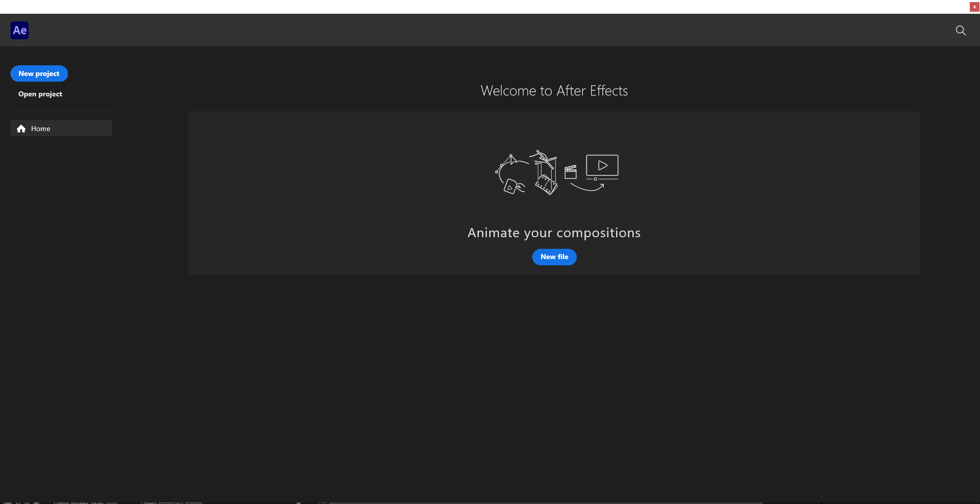
The above is the top window
Now If you click on the New File in the middle of the window then it will wwork as same as teh neww project button but this time a prompt will open telling you to import a video like this
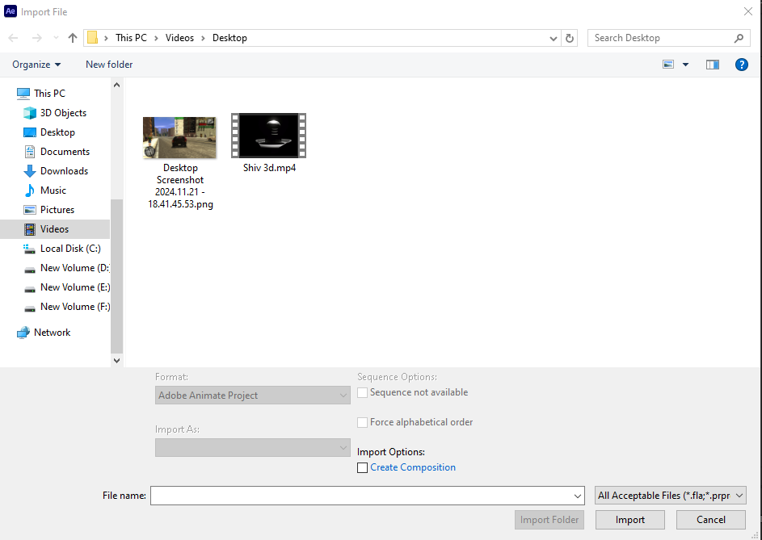
If you import a video then that video will be added to the project window and its composition will be formed and shown in Timeline and project window
but if you close the import window and does not import anything then the bottom window remains containing untitled new project
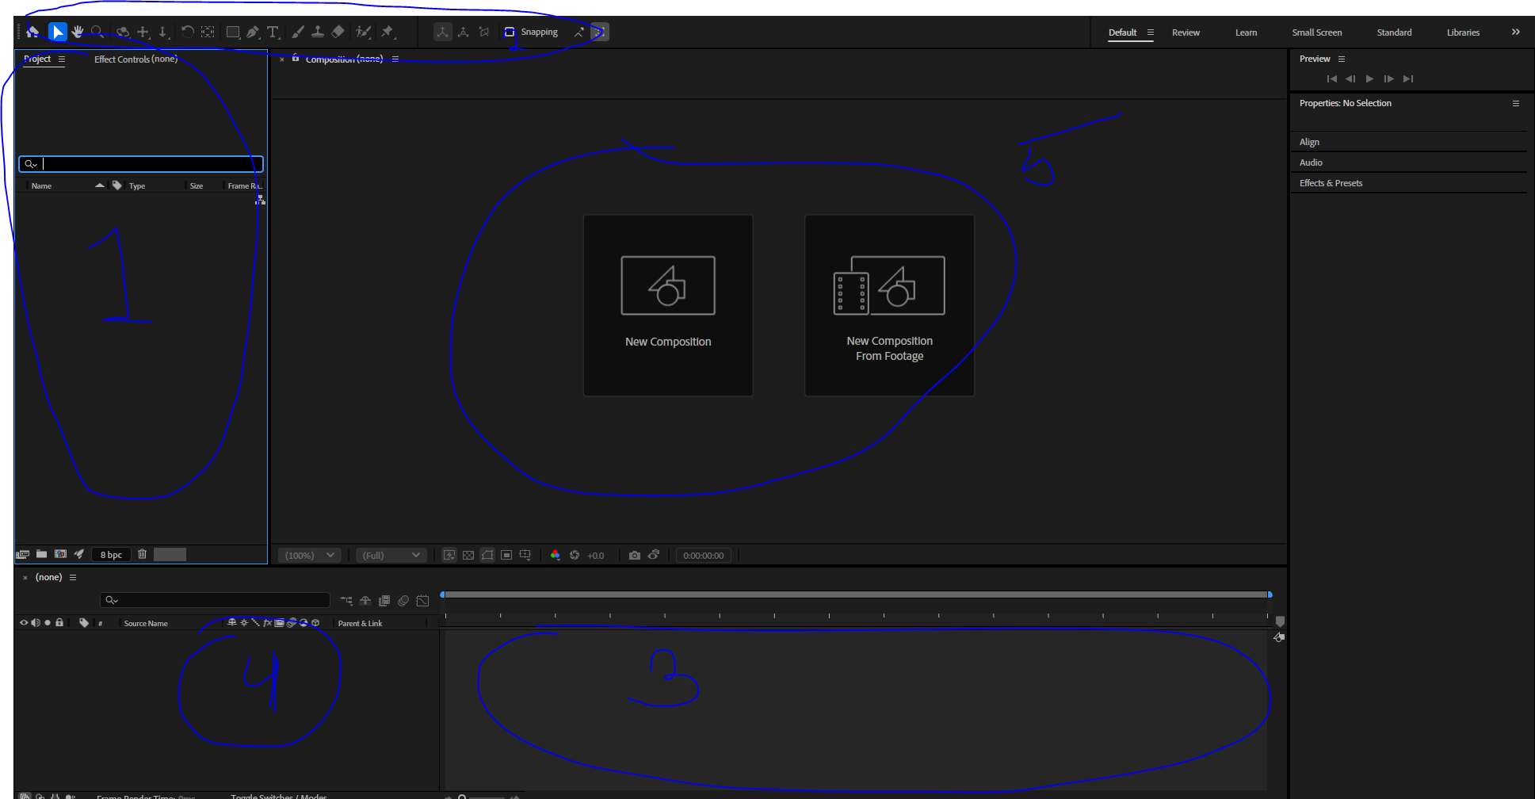
The above is the bottom window and the UI or interface of the After effect
The marked 1 above is called project window
The 2 marked one is the toolbar
eventually we will see tools also
The marked 3 is the timeline and in the marked 4 is where the list of layer will be shown
From what i remember is that The bottom window will be named after the video you imported first (who knows)or the name you gave to composition
Marked 5 is composition window
What is a composition we will see it
One of the way to make a composition is by right click on the Project window and then in submenu click on the new composition
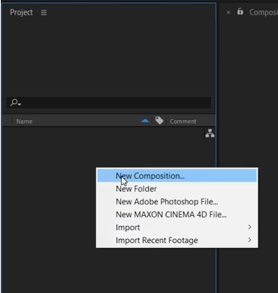
and a new window will be opened as shown below

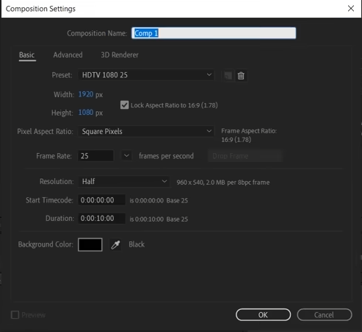
Now click on OK button
A new composition wwill be formed and will be shown in the side of timeline panel(where layers are showed) means marked 4

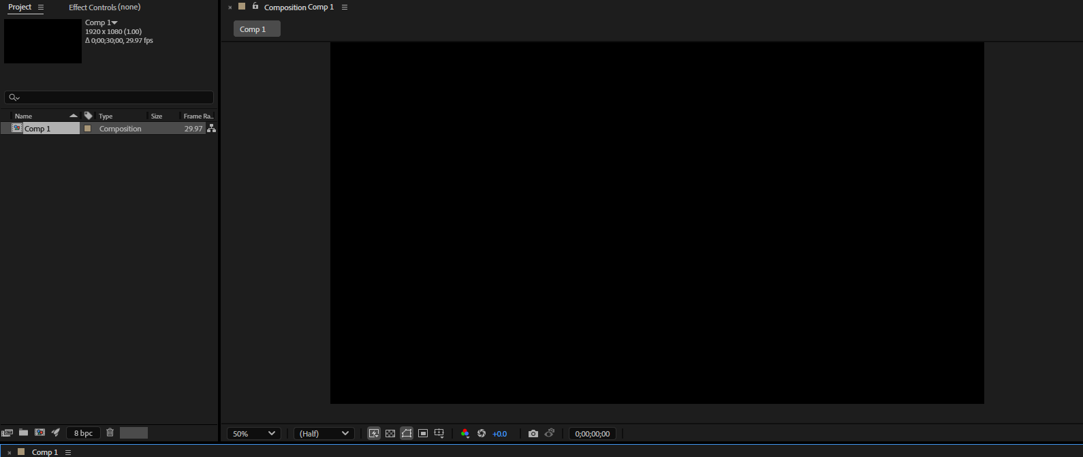
The black screen you see in composition window is your main video of the composition you made
The animation or video you are working on you will see there
In Project window you import your whole content
For example you want to add a video or an image, audio It is also used to happen in Premium pro (who knows)
you don't have to learn premium pro to learn after effect
If you double click on your project panel(lower part) then browse window will be opened to import your content as shown below
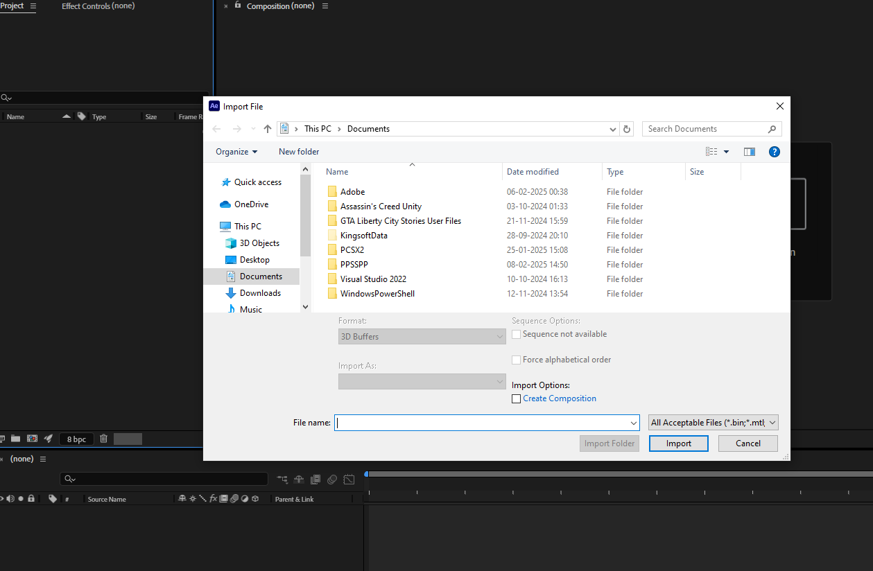
choose your content by clicking on the content in the browse window and then click on the import button we have imported an image as shown below
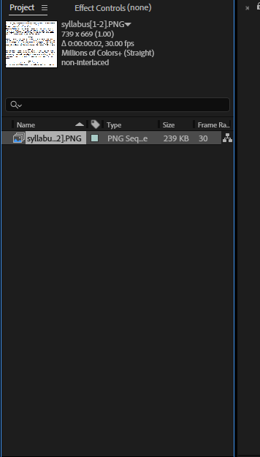
if you select a content by clicking on it then its small preview with some of its detail will be shown in the upper part of the project window as shown above
You can use this content in our video in making by dragging it on the Composition window or directly on the timeline window as demonstrated below
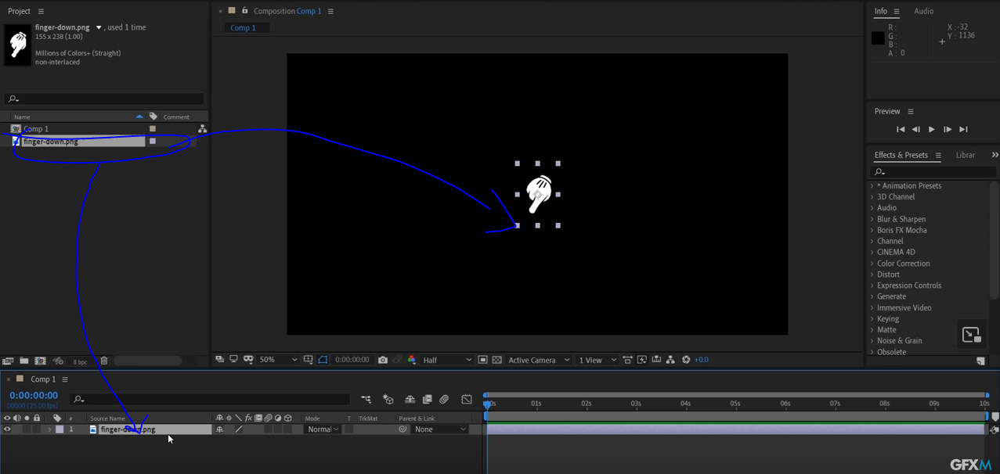

The timeline of the composition made is of 10 second because we made it so when we made the composition
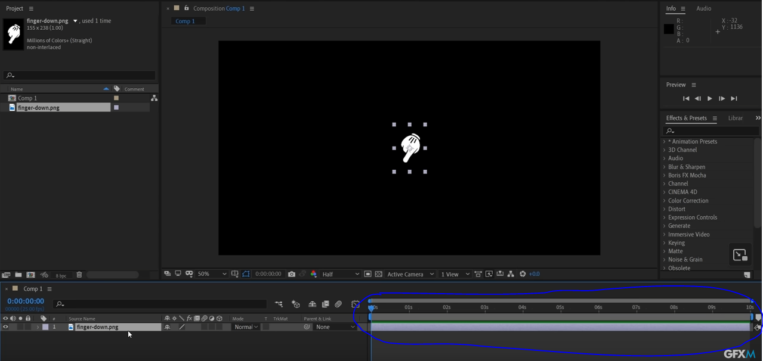
The above marked one is the tiemline and the section of the window beside the marked area is the layer of the contentr in composition
How to make composition and what are its properties we will see it in next class
Teacher is giving us some idea now is that we can animate anything
by just selecting the content present in the composition window and then in the timeline panel expand the layer related to the selected highlighted due to selection and then expand the transform as shown below
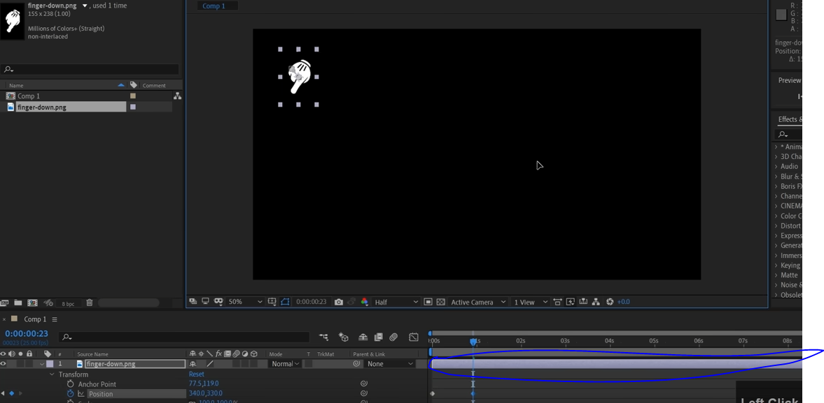
Now click on the clock associaated with the position to add a keyframe where our pointer is in the timeline now move the pointer to the next frame and then change the position now after changing the position of pointer in timeline as shown below
(make sure your content visiblitly is there(means the marked above is long enough that the pointer comes in the timeline so it will be visible when we do animation))

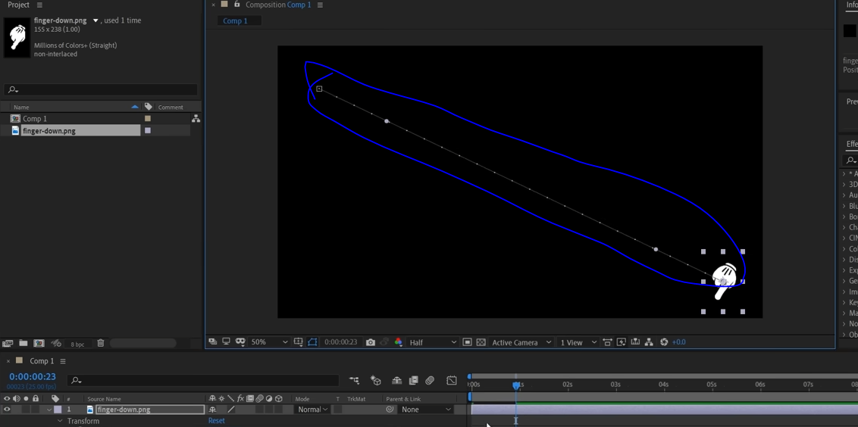

Now it has been animated
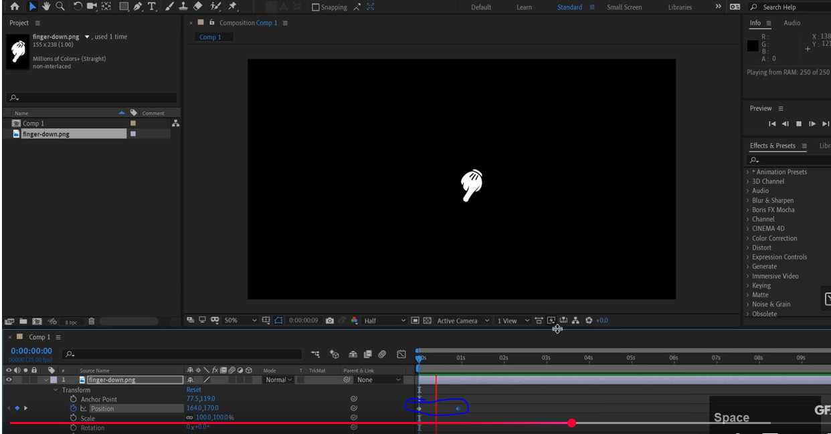

What are key frame we will see it in detail
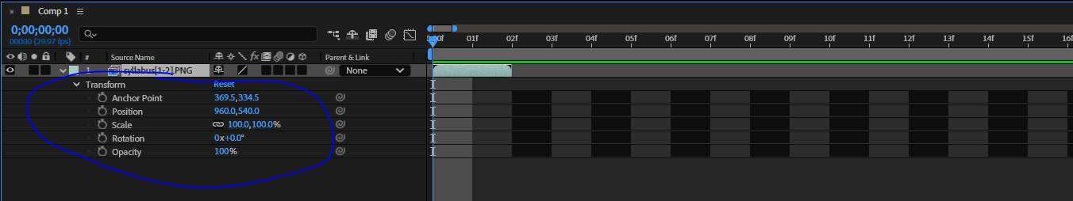
The marked one is our transform property
we can add effect on out layer
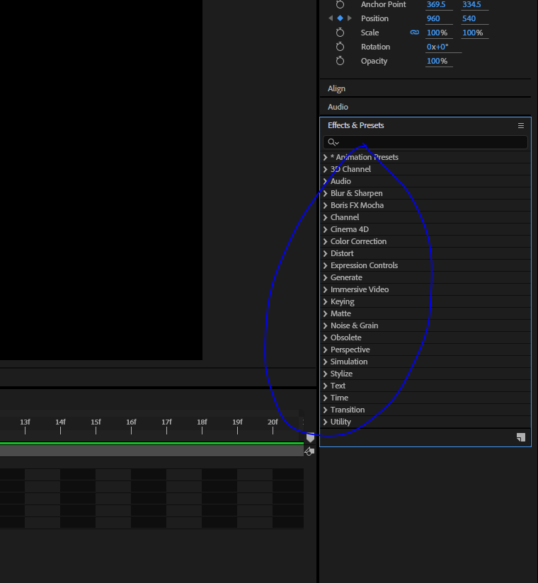
The marked one is the the effect and preset subwindow by this we add effect on our layer
From there we drag the effect aand drop it on the layer that we want to apply it on
for example we apply gaurssian effect on our layer as demonstrated below

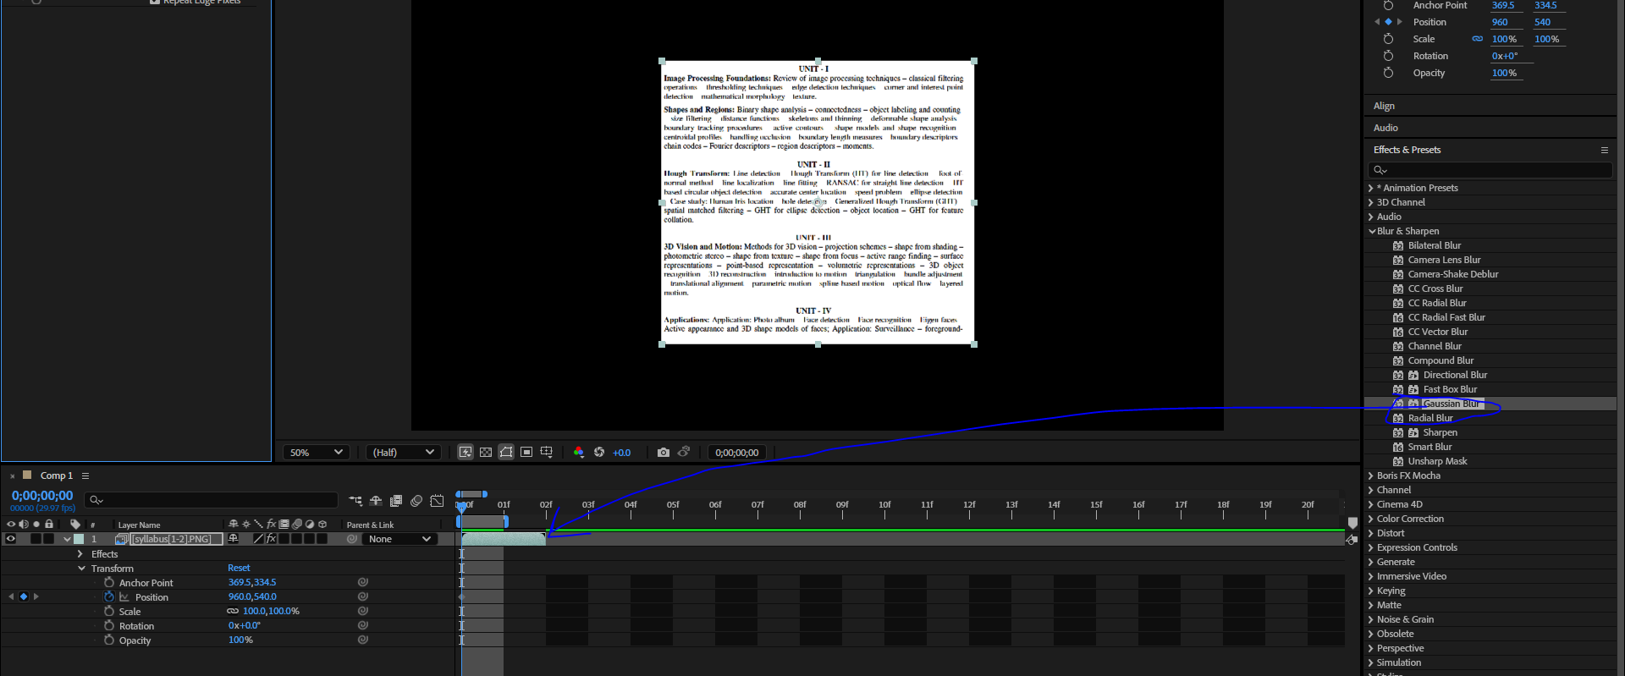
Now to tune this effect or configure ,a new panel named as effect control will be added to the project window
By effect control we can control the effects tht we have applied on the layer
Now as we added a Gaussuaan Blur to our layer when we select our layer and go to Bluriness as marked below and increase the blurines of the layer on which this effect is applied
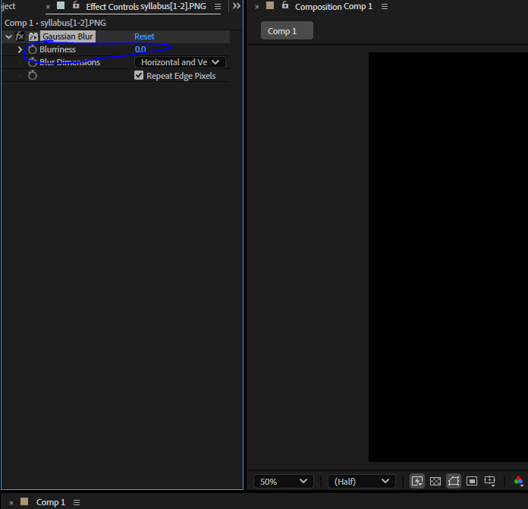
Like we did animate for transform we can animte our effect .
Like different magnitude blur in different point of times.
Demonstration
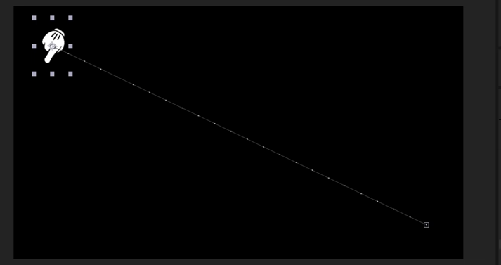
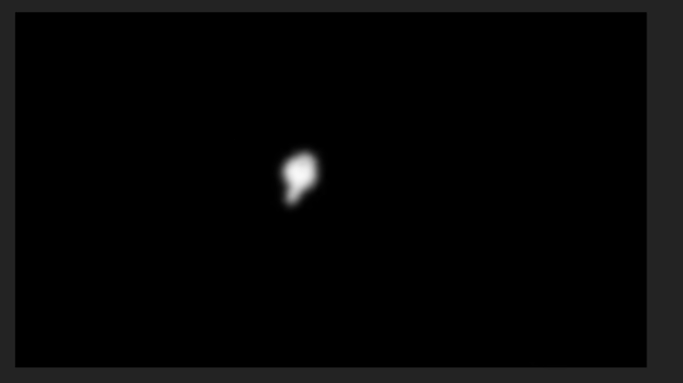
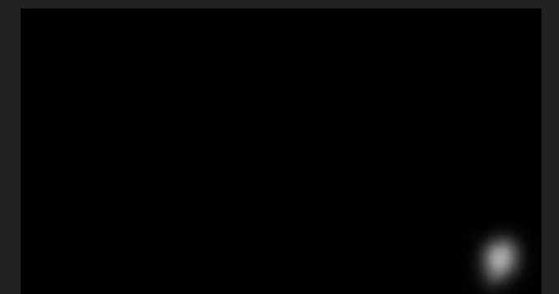
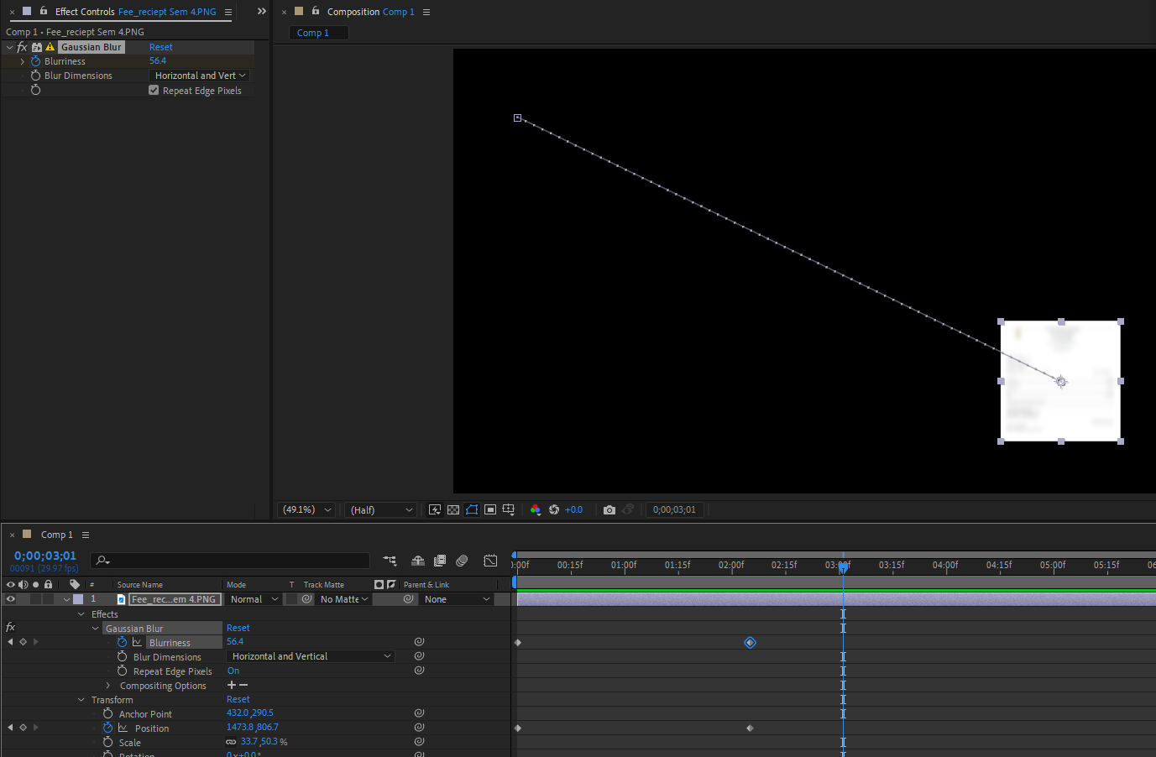
All the effects we applied on the layer could could be controlled or inthe effect property of layer as shown above We could also do anuimation by effect control after selecting the layer that you want to animate
Problem:-
I could not find the way to increase the presense of that content in that timeline in many frames by expanding the marked one of the layer as marked below
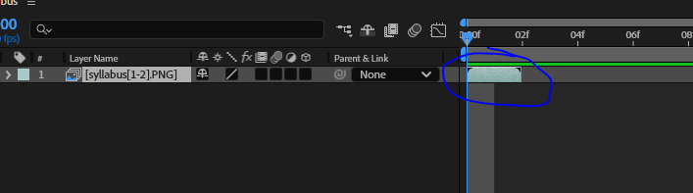
The marked one tell us how long the content will be visible in the which iss represented by its length in the timeline and we can also tell from what frame to what frame that content will be visible with the help of the far ends of the marked one(who knows)
Thats it
So these are the things which we will see definetly further and will go in advance
We will staert from basic
This lesson was just an announcement tht the after effect has started

